**EXPRIMENT NO-3**

**CSA1142-OBJECT ORIENTED ANALYSIS AND DESIGN**

**EXAM REGISTRATION MANAGEMNENT SYSTEM**

**USE CASE DIGRAM**

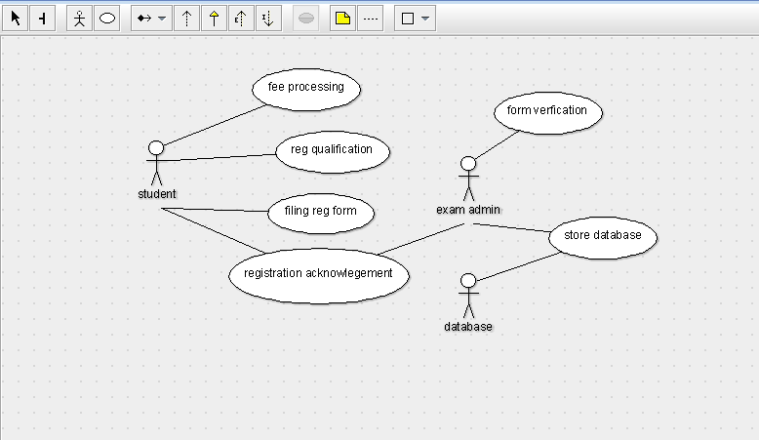

**CLASS DIGRAM**

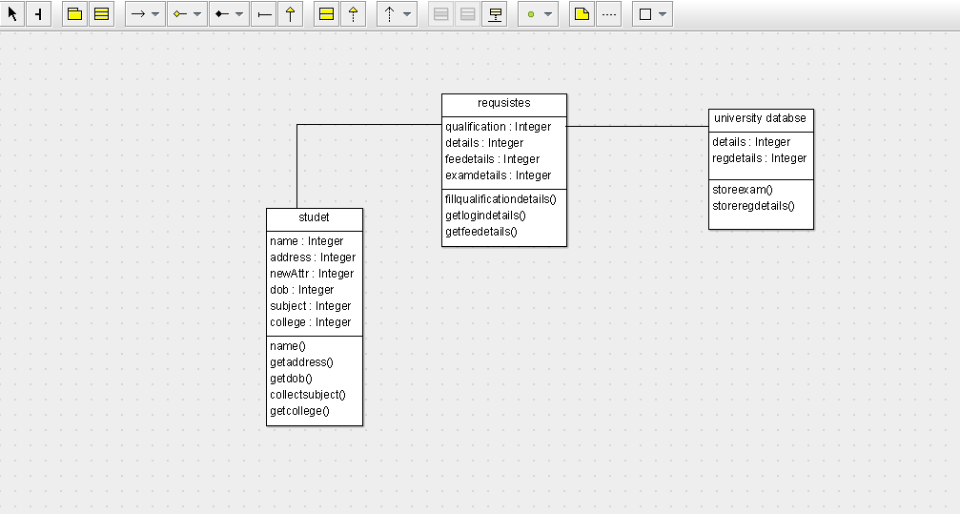

STATE DIGRAM

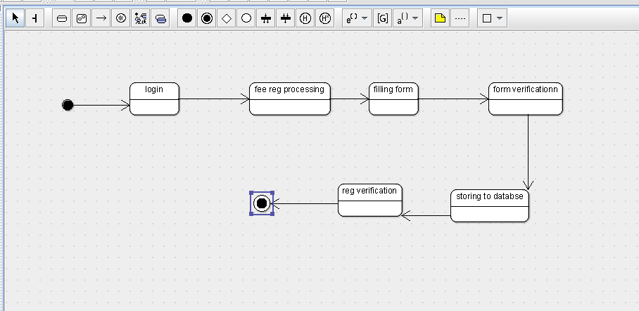

SEQUENCE DIGRAM

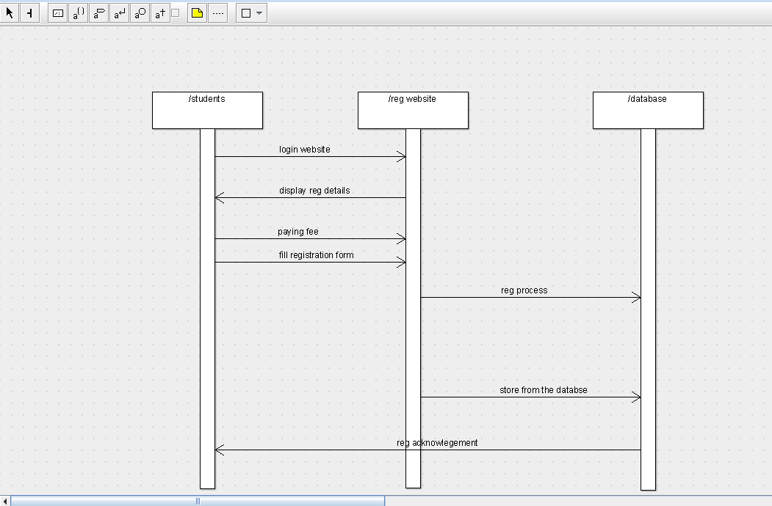

DEPLOYMENT DIGRAM

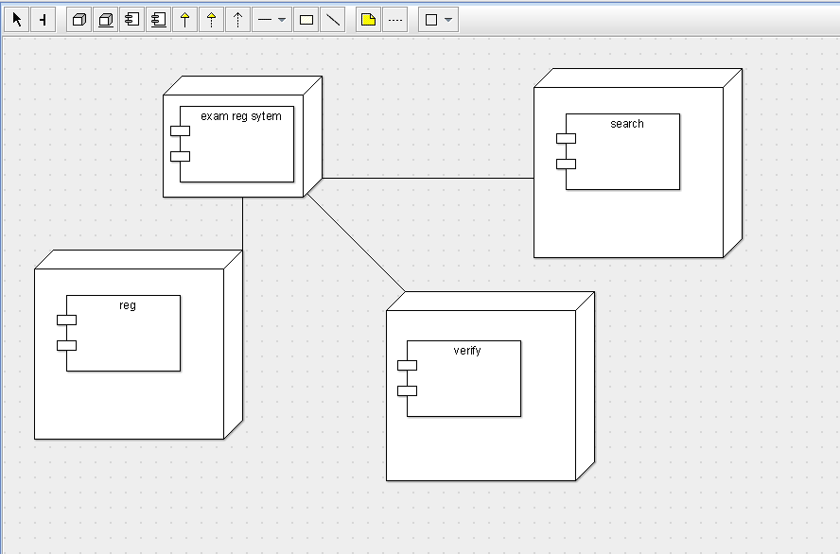

COMPONENT DIGRAM

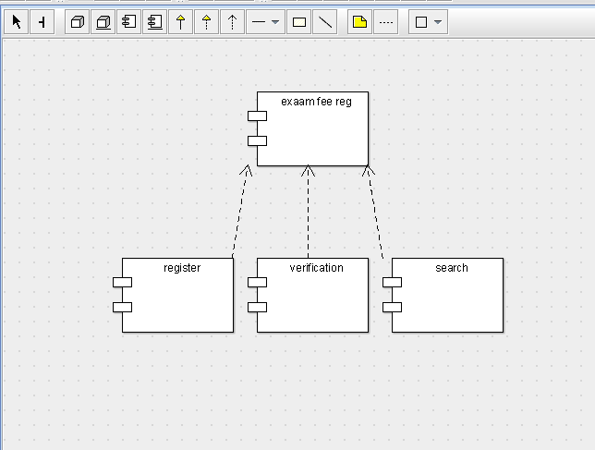

PACKAGE DIGRAM

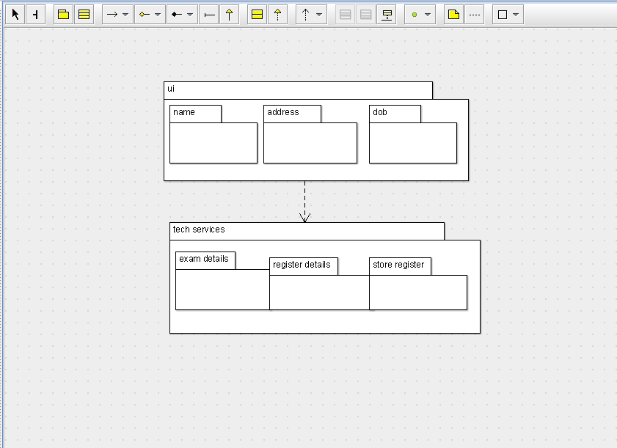

COLLABRATION DIGRAM

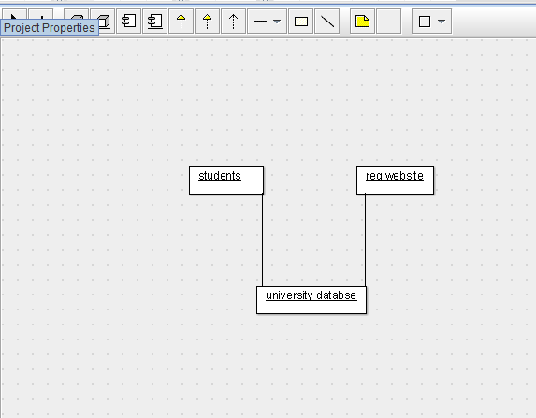

ACTIVITY DIGRAM

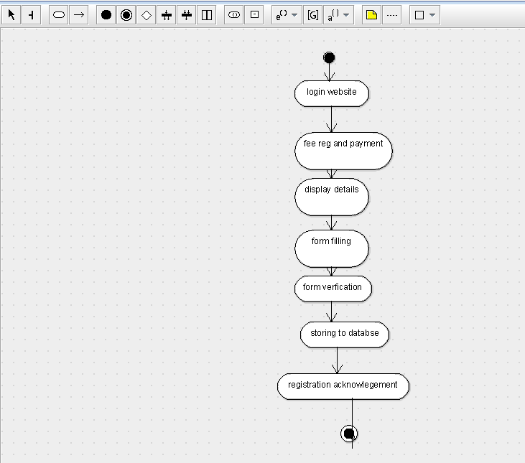

**SKELETON CODE:**

import java.util.Vector;

public class university databse {

private Integer details;

public Integer regdetails;

public Vector myrequsistes;

public void storeexam() {

}

public void storeregdetails() {

}

}

import java.util.Vector;

public class studet {

public Integer name;

public Integer address;

public Integer newAttr;

public Integer dob;

public Integer subject;

public Integer college;

public Vector myrequsistes;

private void name() {

}

public void getaddress() {

}

public void getdob() {

}

public void collectsubject() {

}

public void getcollege() {

}

}

import java.util.Vector;

public class requsistes {

public Integer qualification;

private Integer details;

private Integer feedetails;

public Integer examdetails;

public Vector mystudet;

public Vector myuniversity databse;

public void fillqualificationdetails() {

}

public void getlogindetails() {

}

public void getfeedetails() {

}

}